Adapted from “Application Activities,” by Pete Ostafichuk and Jim Sibley, 2014, In Getting Started with Team-Based Learning eds. Jim Sibley and Pete Ostafichuk, Virginia, Stylus Publishing.

Building great activities for teams
Good team tasks are absolutely critical for making Team-Based Learning work. When a Team activity falls flat we should look at what we are asking the students to do for the source of the real problem. Most often the issue is a poorly conceived team tasks. Some important principles to consider:
- Effective group assignments should promote students’ mastery of basic conceptual material and enhancing higher-level thinking and problem-solving skills.
- Effective group assignments should create high energy levels during class discussions.
- Effective group assignments should promote the development of team cohesion.

The vast majority of dysfunctional student behaviors (e.g., social loafing, one or two members dominating the discussion, etc.) and complaints (e.g., having to carry the dead wood, the instructor isn’t teaching, etc.) are most often the result of bad assignment design, not bad groups.

What a good activity looks like in the classroom
You know you have hit the mark on this when the classroom is full of noise and energy, the discussions are focused on the activity at hand, and you have a steady stream of students asking for additional information as they dig deeper into the problem. Most compelling is when students seem oblivious to the clock and the end of the class period; they continue to discuss the activity and you actually need to tell them to leave the room to make space for the next group coming in. This is a strong indication that the students are engaged with the course material (there is on-task noise and energy) and they enjoy and value the experience (they would rather continue working than leave the room). This is a huge step from the rustle of bags and clicking of binders that instructors must typically endure for several minutes before the end of a lecture.

For creating an effective Application Activity, the guiding principles in TBL are known as the 4 S’s.

The 4 S’s
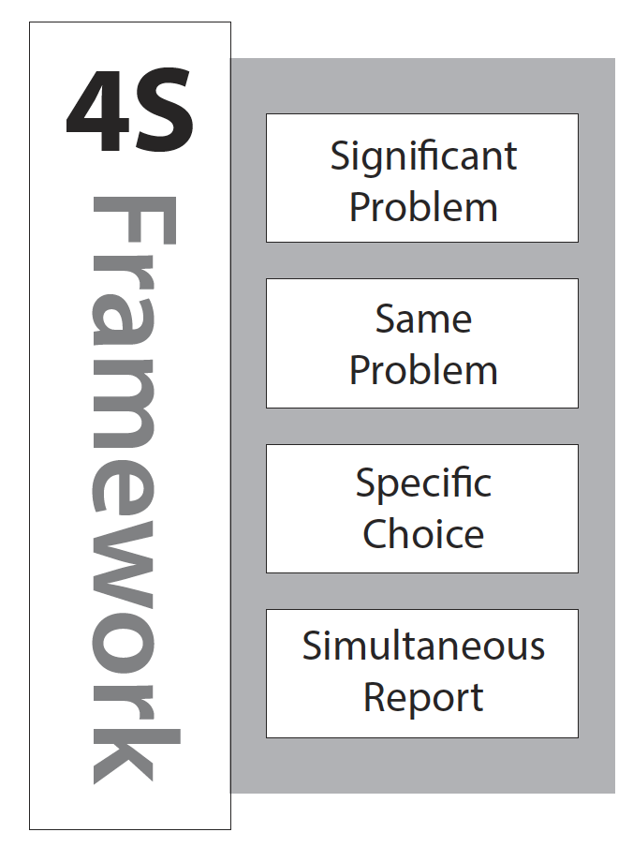
Significant problem reminds us that the problem must be meaningful to the course and rich enough to engage the whole team. A trivial problem that can be solved by a single person working alone does not make a good team Application Activity. Rather, we should be seeking a complex problem with incomplete or contradictory information where a diversity of perspectives is an asset. Churchman’s concept of a “wicked problem” (Churchman, 1967) captures some of the essence of a significant problem in that it is resistant to resolution, or at least does not have an obvious solution.

Same problem refers to having the entire class work on the same problem at the same time. The rationale is that by having all teams work on the same problem, they will have a greater engagement and investment when it comes time for a class-wide discussion or debriefing. Having a deep knowledge of the problem will allow for a more informed critique of other teams’ work, not to mention a more engaged and passionate critique if other teams arrive at a conflicting conclusion for the same problem. This approach is in contrast to the common practice outside TBL of having each team work on a different problem so they can share what they each have learned; without having everyone work on the same problem, each team becomes the “expert” of their own topic, which does not invite challenges or contradictory conclusions in the same way.

Specific choice requires that teams be able to express their solution to a problem by means of an easy-to-describe choice. Before giving some examples of what a specific choice might look like, it might be helpful to consider some examples that are not specific choices: a multi-page report, an oral presentation, a demonstration of a functioning device or process, or an ordered list, to name a few. Creating these deliverables may be valuable experiences for students and may even relate to some of the course outcomes, but they do not lend themselves well towards TBL Application Activities. Instead, the specific choice of a good Application Activity requires that the team members all come to agreement on a single, clearly-defined answer in light of potentially vague or conflicting information. Having teams make a specific choice also makes it possible to quickly see and compare responses between different teams (part of the next “S”). Posing multiple-choice questions is one of the most common ways to require a specific choice, provided the question is not trivial — that is, the problem is significant, as described above. There are many other approaches too, such as an open prompt requiring a one- or two-word answer, a task involving identifying a specific feature or location on a drawing, chart, or map, or a task involving specifying a value (e.g. minimum profit or maximum safe dosage). The choices available to the teams need not necessarily have a clear “right” answer — the purpose is to stimulate discussion and application of the course material, and to require teams to support and justify their thinking.

Simultaneous reporting is the final “S”, and it requires that responses from all teams are reported to the class at the same time. Requiring the response in the form of a specific choice (the previous “S”) makes simultaneous reporting possible, because a specific choice is easy to report. Simultaneous reporting encourages team accountability, since each team knows their response will be available for all to see, and no team wants to stand out with an unreasonable, hastily-chosen answer because they did not put the same thought into the problem as the other teams. Put another way, the public commitment that comes with simultaneous reporting motivates the teams to seriously engage in the activity. There is also a fairness that comes with simultaneous reporting, since no one generally wants to be “picked on” first. More importantly, there is no opportunity for later teams to unfairly modify their answer based on the responses of earlier teams, since everyone commits to their answer at the same time. Finally, simultaneous reporting creates anticipation, excitement, and engagement in the classroom; teams want to see how their response compares to those of their classmates. Techniques for achieving simultaneous reporting follow naturally from the type of specific choice the teams make.

As a final note, it is the revealing of the choices to the class that should be simultaneous, not the recording of the choices by the teams. For example, teams could report their answer to the teacher or teaching assistant by a certain cut-off time in the class, the teacher can record these answers as they come in (perhaps on a laptop or an overhead transparency), and then the teacher can reveal all answers at once using a digital or overhead projector. A common facilitation approach in these circumstances is the “last to report, first to talk” rule.

Before moving on, it may be helpful to examine several example Application Activities to get a sense of what they might look like in practice.

Example 1: Active and passive voice with voting cards

Consider the following exercise (adapted from Michaelsen, Fink, & Knight, 2004) to be presented to teams in an English class:
Imagine you are an English teacher and you are working with your students to develop their understanding of the active and passive voice. You are trying to develop their next assignment. Which wording in the following assignments would best promote higher-level thinking and a rich reporting discussion?
- List the mistakes writers frequently make that detract from their efforts to write in the active voice.
- Read the following passage and identify a sentence that is a clear example of (a) active and (b) passive voice.
- Read the following passage and identify the sentence in which the passive voice is used most appropriately.

In advance, teams are given three large coloured cards prominently labeled A, B, and C. After an appropriate time for teams to discuss and determine their choice, the instruction is given for teams to simultaneously hold up their cards (for example, “on the count of three, hold up your choice”). A teacher-facilitated discussion of the class responses follows.

To highlight the 4 S’s in this example:
- The problem not only requires an understanding of what differentiates active and passive voice, but also an ability to critically evaluate the effectiveness of potential learning experiences in enhancing student understanding (significant problem).
- All teams work on the same scenario at the same time (same problem).
- Each team chooses one of three possible answers (specific choice).
- All teams reveal their choice at the same time by holding up a coloured voting card on cue (simultaneous reporting).

Example 2: Location for dry-cleaning business selected using a pushpin

In this second example (adapted from Sweet and Michaelsen, 2012), imagine an economics course in which teams are tasked with identifying the best location for a business:

You are consulting for a new business owner who wants to open a dry-cleaning store in Norman, Oklahoma. Where would you recommend locating a new dry-cleaning business (and why)?

A street map of Norman, Oklahoma is placed at the front of the room and each team is given a pushpin. At the appointed time, after teams have had time to analyze the scenario and reach a supported conclusion, each team sends a representative to the front to indicate their chosen location on the map using their pushpin. The scatter of pins on the map creates a natural motivation to understand other teams’ thinking in determining their choices. A teacher-facilitated discussion of the class responses follows.

This example also makes effective use of the 4 S’s.
- Drawing from their course material, teams must analyze the business and location characteristics, identify and appraise possible locations, and recommend and justify a location based on an evaluation of the potential options they have identified (significant problem).
- Again, all teams are tasked with the same case to analyze (same problem).
- Each team has a single pushpin to indicate the location for their business on the map (specific choice).
- All teams place their pushpins at nearly the same time (simultaneous reporting).

As teams also need to be prepared to support and defend their choice during the class discussion, there is little concern of a team changing their decision at the last second if they happen to see a difference between their choice and other teams that have already placed their pins.

While the 4 S’s are invaluable in guiding us to the elements of an effective Application Activity, it remains to actually construct the exercise, structure a class or classes around it, and facilitate the activity.

Structuring an Application Activity
Setting things up
The typical team exercise day will start with an introduction. I usually take anywhere from 5 to 15 minutes to introduce the exercise and talk about the context. One of the things I'm learning to do a better job of, and I think I'll try to do even more, is develop really clear learning objectives for each exercise. I haven't done that as much as I would like to, but I’m kind of learning that as I go. I want to be able to explain, ”Here's what we're doing and here's why. This type of situation would come up when you're a practitioner in this type of case”, and I can do this both before as well as after the exercise…
Mark Stevens
Community and Regional Planning
University of British Columbia

The organization of an effective TBL Application Activity parallels that of any effective teaching activity; it needs a well-thought-out structure with a beginning, middle, and end. There are many frameworks used to describe such structures, but they generally have the same elements grouped in different ways (often with colourful acronyms too: BOPPPS, MMUCKO, and such). I will use one of the simpler top-level frameworks to describe structure: Set, Body, Close. Feel free to adapt your personal favourite if you have one.

Set, Body, Close is highly adaptable for almost any size group and any duration. It aligns, respectively, with the beginning, middle, and end of an activity or lecture. The Set portion sets the stage and primes the learners for what is to come; most importantly, it establishes the tone, conveys why the topic is important, and outlines the objectives. The Body is the core of the class; in a conventional lecture, this would be where the teacher delivers content, while in a TBL class, this is the Application Activity (including teams working on the exercise as well as the discussion and debriefing that follow). Finally, the Close wraps everything up. It summarizes the class or activity, emphasizes what has been accomplished, and relates the outcomes to the objectives from the Set.

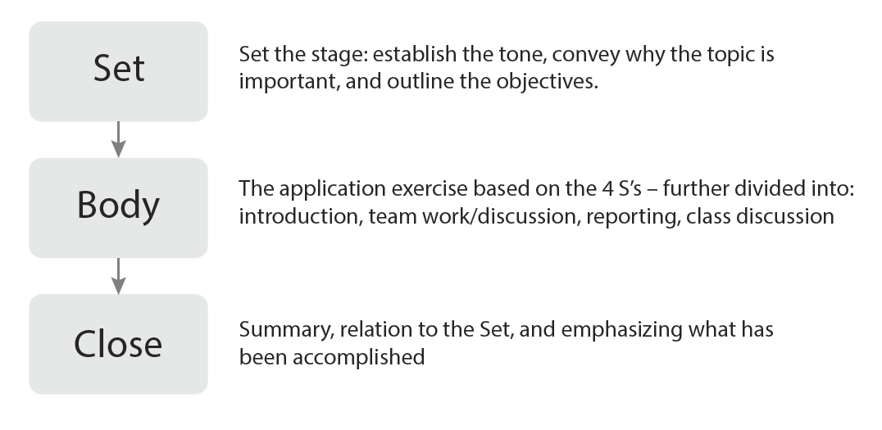
The Set-Body-Close Structure

In facilitating a TBL activity, the teacher is important through all phases of Set, Body, and Close. The Set and the Close are the primary opportunities for the teacher to engage with the entire class at once. The Set and Close can be particularly useful in a course where learners are new to TBL, as they allow you to highlight why you believe the team Application Activity is superior to some other teaching approach. It is a chance to make a “sales pitch” for TBL and to ease some of the student trepidation and resistance that might otherwise come forward when trying something new. If an activity falls flat, which does happen from time to time, the Close gives an opportunity to gracefully acknowledge that and still achieve some or all of the learning outcomes that were set forth.

Put another way, the Application Activity is the Body, and the Set and Close are there to frame and support it and reinforce the learning. With properly-designed Application Activities, student focus naturally shifts from identifying the “correct” answer to examining the thinking and supporting evidence behind a decision. Highlighting this to the class and reinforcing this shift in focus is important in the Set and Close. The Body of a TBL Application Activity also deserves special attention; as we will see in the next section, there are many techniques and approaches around which this can be constructed.

Facilitating an Application Activity

The Body of the Application Activity can be further divided into four stages: exercise introduction, team discussion and work time (also called intra-team discussion), simultaneous reporting, and class discussion (also called inter-team discussion).

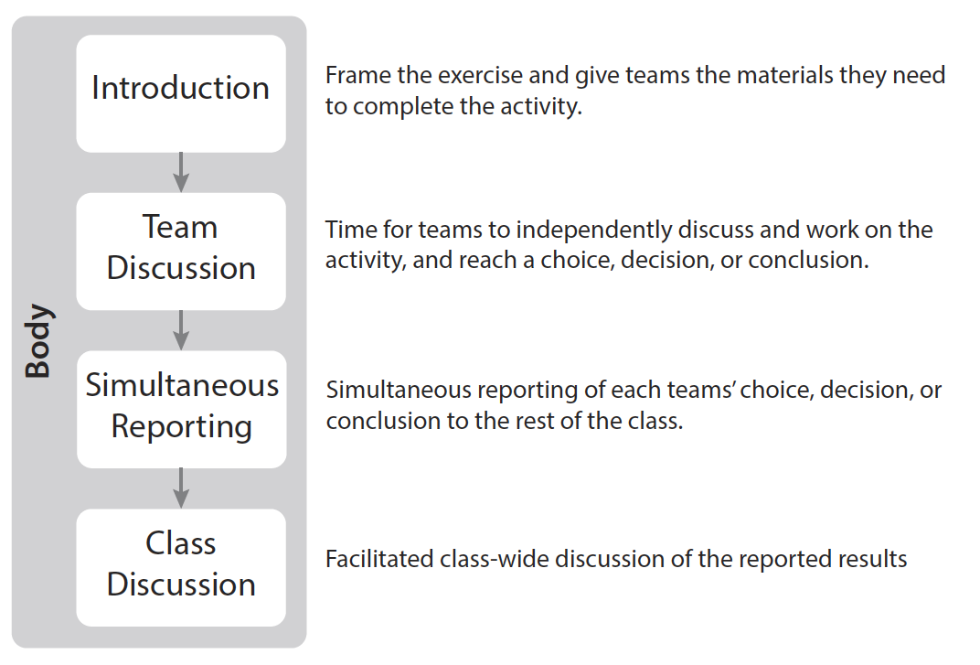
The Stages of the Application Activity Body

In introducing the exercise, teams are given the required materials they need to complete the task. Having handouts and other materials already prepared in team folders can expedite the distribution process and also conveys the message that thought and effort has gone into the activity and its preparation. The introduction is also used to orient teams to the activity in terms of the time available as well as resources, applicable knowledge, and skills they should draw from. Finally, this is an opportunity to remind teams specifically what outcomes are expected, including the specific choice they are to make as well as any deliverables or supporting information they should have available.

The team discussion and work time (intra-team discussion) is the time for teams to complete the activity. Thinking of the 4 S’s, this is where teams apply the course material towards the significant problem and make their specific choice. This is also the time when teams prepare whatever is needed to report their choice, as well as any supporting materials they anticipate may be required during later class discussions. It is not uncommon to also have students prepare worksheets, summaries, or other deliverables to submit at the end of the activity, perhaps for marks or perhaps not. The teacher’s role during this stage is typically an active one and requires constantly checking in with teams. Moving from team to team and engaging with students emphasizes that the activity is important and valued. In addition, this gives an opportunity to track team progress for the sake of activity timing, as well as to anticipate possible issues. Questions from teams can be addressed — or not — as they arise. The role of the teacher, monitoring team conversations and managing the activity time during the team discussion phase.

Knowing how teams are progressing helps you determine if there is a need to pause the activity and provide additional information, clarification, or even a mini-lecture if many teams seem to be excessively struggling. This is not to suggest other views of the teacher’s role are not possible; Sandy Cook has noted that facilitators at the National University of Singapore found “being in the room meant that the students spent more time trying to weasel the answer out of the faculty,” so now the faculty sit in another room while the discussion is taking place.

The simultaneous reporting portion of the exercise is where the different team choices or responses to the problem are revealed to the class. There are many approaches to manage and achieve the simultaneous reporting, and a small sample of some techniques is described in the next section. Though there are many techniques for this phase, the essential elements are the same: all teams’ choices are revealed at the same time (which requires each team to commit to their response prior to seeing any other teams’ responses) and differences in team choices are immediately and clearly available for all to see.

The class discussion (inter-team discussion) follows immediately or shortly after the simultaneous reporting. This is where teams have an opportunity to examine other teams’ methodology and challenge their decisions. By the same token, this requires that teams be prepared to defend their own choices and decision-making process. Contrasts in student thinking revealed by the simultaneous reporting naturally lead to the class discussion. In some cases, teams may eagerly seek the opportunity to challenge contrasting opinions or decisions, while in other cases; teams may need a little coaxing from the teacher. Either way, the conversation naturally tends to focus on the thought process or support for the decision, rather than which answer is the “correct” one.

The teacher’s role during the class discussion stage is to facilitate the discussion, while resisting the temptation to join in the discussion. It is important to ensure all team voices are heard, and how this is done will depend on the class personality, the norms that have been established, and the confidence teams have in their answers.

One approach to aid in starting the dialog is to begin with the group of teams with the most common response and ask for one of those teams to volunteer, or randomly select one of them to speak first, and have them defend why they believe their response is well-justified. Another approach is to give teams some time, perhaps two or three minutes, to formulate questions for other teams. Lastly, it is typical that the teacher calls on an entire team to answer rather than an individual, but it is worth considering whether this is the best approach for your class.

(M. Stevens, personal communication, January 10, 2013)

