Team-Based Learning: Effectively flipping your course
Team-Based Learning (TBL) enables you to realize the full potential of the flipped classroom by providing coherent organizational structures to design your course. TBL is a unique and powerful form of small group learning that was developed at the University of Oklahoma Business School in the late 1970’s. There are two main questions you need to ask when thinking about flipping your course. First, “how can I ensure my students prepare?” Second, “when students are prepared, what am I going to do with the “free” class time?” The goals at the heart of these questions are achieved by using TBL’s Readiness Assurance Process and team application activities.

Getting students prepared
Prior to class, students use assigned preparatory materials (textbook chapters, articles, videos, etc.) to learn basic content. In class, the Readiness Assurance Process (based on these preparatory materials) uses a clever sequence of individual and team tests to unleash the power of social learning. The Readiness Assurance Process process converts student pre-class preparation into true readiness to begin problem-solving. The next step is team application activities.

Helping students apply course concepts
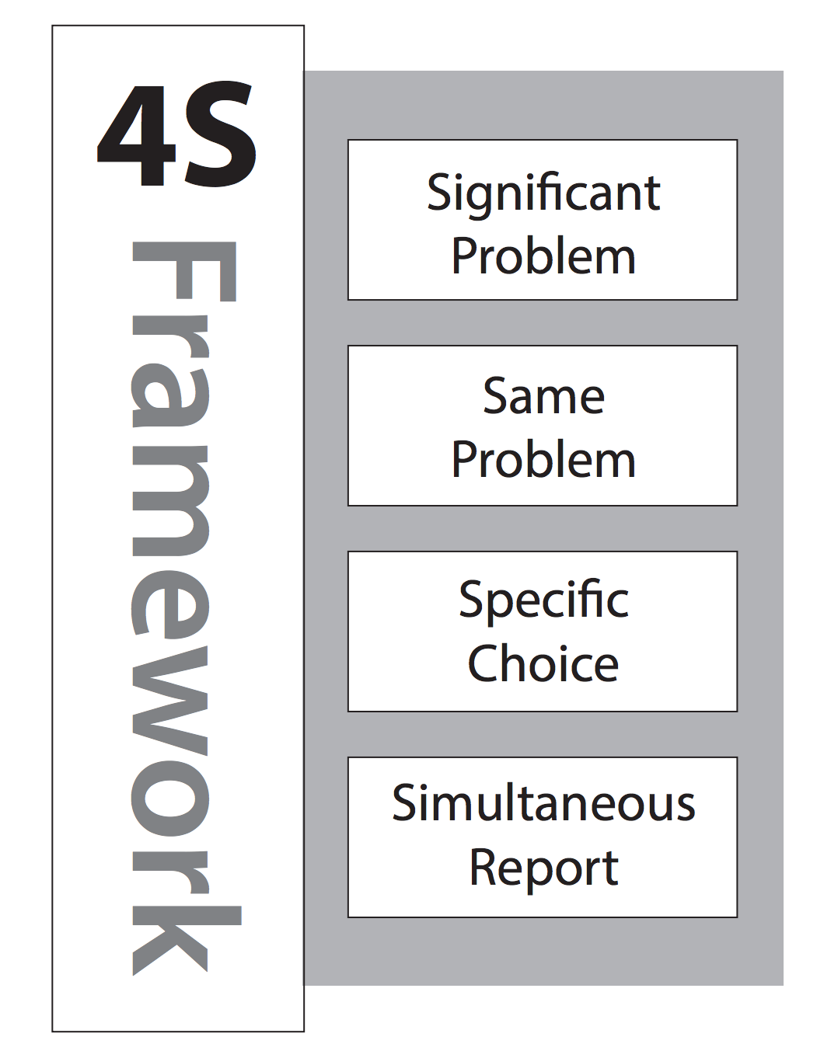
The majority of class-time is spent on team application activities where student teams learn how to apply the course concepts to solve relevant and interesting problems. These application activities use something known as the 4 S framework to structure and guide problem-solving and decision-making events. The 4 S structure let’s you consistently build problem-solving events that naturally lead to spirited discussions about the application of the course content. When you ask the right kind of question - one that requires both consideration of complex data and careful discrimination between reasonable options - powerful things can happen. The consideration of viable options that require deep, complex analysis is the holy grail of TBL.

Here is an example question.

You are designing a bridge for the local salt-water marina. What bridge building material would you recommend? and why?
- Wood
- Concrete
- Steel
- Aluminum

When teams simultaneously report their application activity decisions, any contrasts in thinking are immediately apparent. These contrasts then allow the instructor to facilitate intense give-and-take discussions. Teams get immediate focused feedback from other teams on the quality of their thinking. Following simultaneous reporting, teams challenge other teams’ decisions and may be required to defend their choices by explaining their rationales. During these application activities, you get to see the true power of TBL and the flipped classroom when teams are making decisions, publically committing to them, and then deeply discussing their decisions.

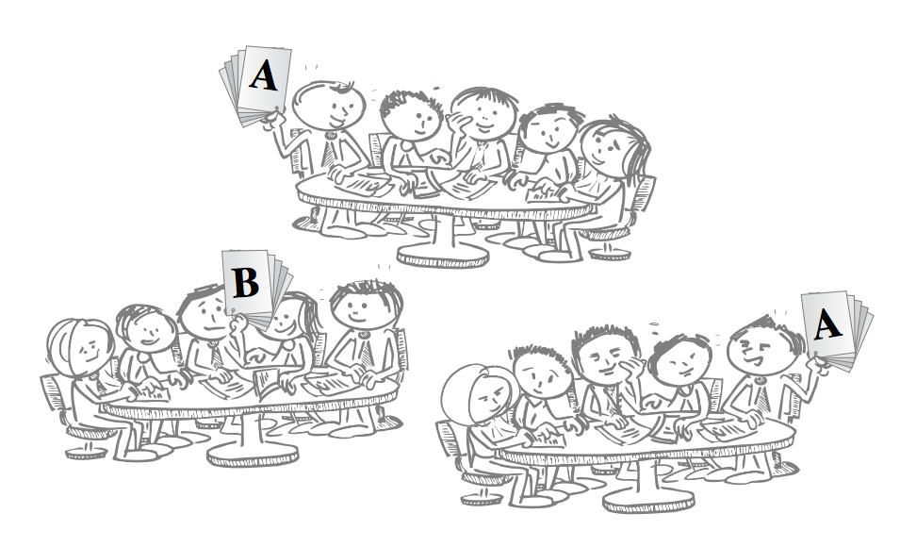

TBL is a powerful pedagogical and instructional framework that gives you some proven and reliable structures around which to build your course. Because TBL classroom activities are built on students giving students feedback, TBL scales very well to large classroom settings (200-400).

Getting started
To learn more about TBL, visit teambasedlearning.org or read Jim Sibley and Peter Ostafichuk’s new book by Stylus Publishing “Getting Started with Team-Based Learning”

