Some Learning Theory

Our Dreams

Most instructors’ dream of imparting important, enduring knowledge to their learners, and hope that their students become self-motivated, expert problem-solvers with a sophisticated world-view. Most of us often fall short of these dreams in courses crammed with content, classrooms designed for lecturing, and contexts that - sometime quietly and sometimes overtly - support the status quo. At the beginning of our teaching careers, we often dwell on our role as instructor with little regard for what is going on in students’ heads. It is important to remind ourselves that a high quality learning experience depends on a change in student thinking and understanding, and not necessarily on the instructor believing they ‘taught well.’
A story to help understand the social construction of knowledge. Consider learning something new; you research, you read, you study and get some basic understanding…say maybe 70% understanding, then you try to use your new knowledge to maybe solve a problem…maybe it doesn’t work so well… you find someone else learning the same thing…maybe having the same struggles, and as a result of the conversation between you and the other learner you both begin to construct shared meaning – this process of social construction can get us to a higher level of understanding.

Without the social interaction we can’t compare our thinking to others’ thinking or against disciplinary thinking. Fostering these conversations are at the heart of constructivist teaching.

Constructivism is an educational theory that espouses that learners construct knowledge and meaning from their experiences. Constructivism’s guiding principles are: knowledge is constructed not transmitted, prior knowledge impacts learning, and building knowledge requires effort and purposeful activity.

Social Constructivism espouses that learners needs to arrive at their own version of the truth, and this process will be influenced by their background, culture and embedded worldview. Learners construct shared meaning by having social interactions with other people, especially with a more knowledgeable other (MKO).

Some Educational Theorists
Jean Piaget

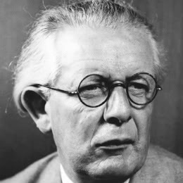
The Swiss educational theorist Jean Piaget (1896-1980) first espoused the idea that learners either assimilate new information or shift their way of thinking and organizing what they know to accommodate the new information. Sometimes new information can be neatly ‘assimilated’ into students’ existing understanding of the world, and sometimes their worldview needs to shift or ‘accommodate’ the new information. The process of shifting one’s framework of thinking can be a difficult and uncomfortable one.

Piaget also conceived that intellectual development occurs in 4 stages:

- Sensorimotor - early life exploration of environment
- Preoperational - increasing language proficiency and interacting with the world in a progressively deeper way – still unable to understand concrete logic and have difficulty mentally manipulating information.
- Concrete Operational - characterized by inductive logical thinking with limited abstraction. Demonstrates beginning abilities to use reverse thinking and generalization.
- Formal Operational - abstract thinking and systematic problem solving thinking becomes the norm.
Piaget originally conceived that people moved into the last stage, Formal Operation, by age 12. There is now considerable evidence that many adults live their entire lives at the Concrete Operational Stage. We can be at different stages at the same time for different domains of knowledge, for instance being at Formal Operation in one domain of knowing and Concrete Operation in another. When our student come to us, they are likely in the Concrete Operational Stage. Learners in the concrete operational stage, when faced with abstraction, creativity, and ambiguity, often react by memorization and are unable to use course material to solve novel problems. These students will attempt to succeed by rote memorization, partial credit, and repeating courses. They will shy away from open-ended problems and are often unable to learn from their mistakes. If you teach a course that requires higher-level thinking or complex problem solving, and yet some students claim “it is all memorization”, they are likely stuck at the Concrete Operational stage.

Lev Vygotsky

Authentic problem solving can give students the opportunities to use new information and fine-tune their understanding. When students problem solve with their peers they can often progress more quickly than when they work alone or interact with an expert. Working with peers who are at a similar or slightly higher level of understanding can speed a student’s progress. The positive effect of working through and completing a task that is slightly more challenging than one’s current abilities, and progress that is hastened by the support of fellow learners, has been described by Lev Vygotsky as the Zone of Proximal Development. The ZPD is often characterized as the ‘zone’ within which a student can solve more difficult problems then they could solve alone. Vygotsky’s ideas have also been used to describe a process that became known as scaffolding, where the instructor can provide appropriate level of instructional challenge and guidance to maximize students’ progress on a particular learning task, and fade from the instructional process as student mastery increases.

There are great contrasts between Vygotsky and Piaget’s views. Piaget’s believed that cognitive development must proceed learning, which contrasts Vygotsky’s belief that learning precedes cognitive development. Vygotsky did not see limits on our progress and believed that with the right scaffolding and social interaction that any learner can make substantial learning progress.

Jerome Bruner
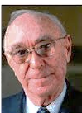
Jerome Bruner is a cognitive psychologist who has made significant contributions to cognitive learning theory. One of his important contributions was Scaffolding theory that he introduced in the 1950’s. Scaffolding comes from Vygotsky’s theory of an expert assisting a novice. Scaffold’s are removable support’s that are provide to the learner when they are new at a task. They can include resources, a compelling tasks, templates and guides, modeling, and coaching. The concepts of scaffolding and fading are cornerstones of many guided inquiry learning models (POGIL-Process Oriented Guided Inquiry Learning; PBL-Problem Based Learning). Fading describes a process in which the instructors may need to provide more guidance early in the student learning process and progressively less as the students’ expertise increases.

William Perry

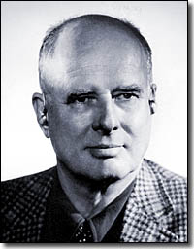
Perry’s Model of Cognitive Development builds on Piaget’s stages of development. He identified the stages students move through as being from a dualist view (black and white, right and wrong) to a relativistic view (other opinions exist, ambiguity exists, different positions have strength and weaknesses). Students will ultimately move to a commitment position where they can weigh the evidence and commit to a reasonable position. The framework typically is simplified into 4 stages.

Duality

Knowledge is certain (Black/White Right/Wrong) and authority is the source of truth. Transition: certainty yields to ambiguity; begins to recognize other points of view

Multiplicity

Uncertainty exists and truth is subjective. Transition: Recognizing mere opinion is insufficient.

Relativity

Uncertainty exists, but some positions and opinions are better than others. Transition: Recognize that mere opinion is insufficient; specific criteria can help evaluate different positions, they must make choices

Commitment

Reasonable, defendable choices may require analysis of imperfect or incomplete data.

Benjamin Bloom
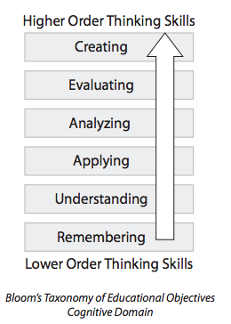
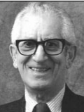
In 1956, Benjamin Bloom helped develop a taxonomy of educational objectives for the cognitive domain to help faculty and students at the University of Chicago graduate school prepare for comprehensive examinations. The cognitive domain taxonomy has since become one of the cornerstones of North American education, as it helps educators use common language around learning goals, and helps individual practitioners articulate the educational possibilities within a particular piece of instruction, course or program.

According to Bloom, in the cognitive domain there are six levels; the lowest being Remembering, moving through Understanding, to Applying, to Analyzing, to Evaluating, and finally to Creating. When designing learning experiences, it can be helpful to use Bloom’s levels to help you visualize and plan students’ cognitive progress as they move through your course. The Bloom’s levels can be mapped to various verbs. These verbs can be used to generate learning objectives and create test questions that correspond to Bloom’s different levels.

